# COMP3000 Computing Project

## 2021/2022

### Project Title

*Audio Authentication via Voice Recognition on QTrobot (AAVR)*

### Links

[Source Code](https://github.com/greatyarn/COMP3000_Computing_Project)

[Trello (Backlog)](https://trello.com/invite/b/stCxAKF8/bacc4ca9cf8aefa46403a2451d15e98f/comp3000computingproject)

### Project Vision

*The QTrobot is a toddler-like humanoid robot built by LuxAI. This project, Audio Authentication via Voice Recognition on QTrobot or AAVR for short is for patients who would like to allow for an easy way to authenticate the QTrobot to be theirs. AAVR is software that allows for audio recognition so that different profiles can be made. With this, patients who have different users can have their settings preferences for the QTrobot can be set on launch. Preferences such as age, height and weight can be recalled from memory when the voice is recognised.*

### Risk Plan

|  |  |  |
| --- | --- | --- |
| **Risks** | **Probability (Low, Moderate, Significant, High)** | **Addressing the Issue** |
| Sprint does not get completed within the allocated time | Low | The sprint that was not completed on time will be moved to the next sprint and be updated on the Kanban Board accordingly |
| QTrobot does not work as expected due to unexpected issues | Moderate | Fixes and patches will be applied accordingly before attempting to move further on with the project |
| Computer that is used stops working due to human error or accidents | Low | Quickly find a replacement device to ensure sprints are done to minimise delays |
| Testing procedures might take longer than usual | High | Do the testing thoroughly |
| Computer might corrupt local disc which causes loss of data that impacts the project | Low | Having local backups and a git version control set in place |
| Getting burnt out on the project due to overwork and stress | Moderate | Having breaks in between and having a good work-study balance |

### Proposed Gantt chart

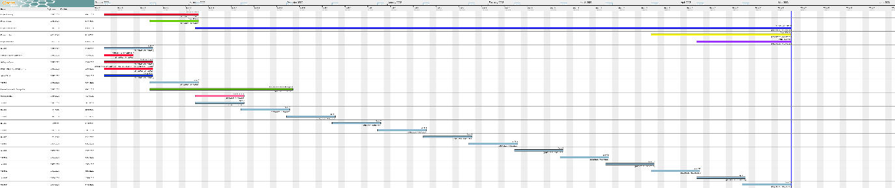

[High Res Image (Imgur)](https://i.imgur.com/vHX4vrA.png), [(Mirror)](https://files.catbox.moe/ze23fl.png)

### Keywords

*Audio, Authentication, Audio Authentication, QTrobot, AAVR, Voice, Voice Recognition, Recognition, LuxAI, Robot,*